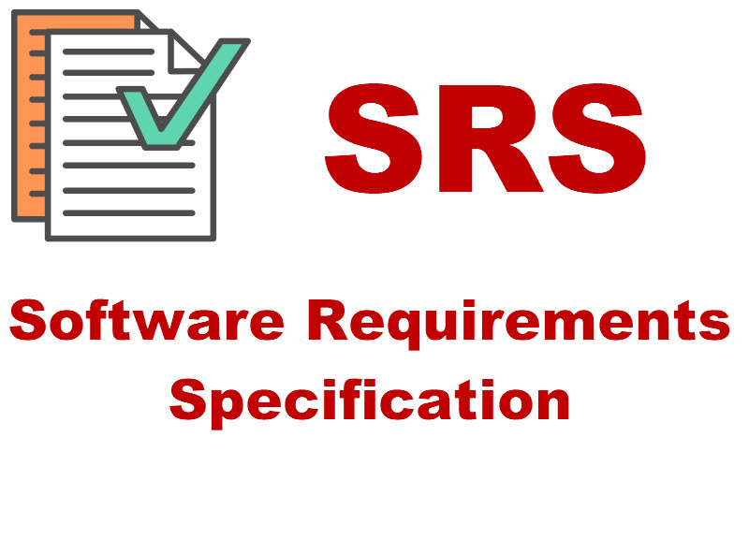

**Web Developer Portfolio**

**SRS**

Contents

**Purpose** 2

**SCOPE** 3

**INTRODUCTION** 3

**Existing System** 3

**Proposed System** 4

**FUNCTIONAL REQUIREMENTS** 4

**NON-FUNCTIONAL REQUIREMENTS** 4

**SOFTWARE TOOLS** 4

**DEPLOYMENT** 4

**HARDWARE SPECIFICATION** 5

**Developer’s Portfolio**

**Category:** Web Development -Portfolio

# **Purpose**

The purpose of developing this portfolio is-

1. Provide a clear understanding of the scope and objectives of the portfolio.
2. Define the functional and non-functional requirements of the portfolio, including user management, project management, user interface, search and filtering, technology stack, security, analytics, and support and maintenance.
3. Establish a common understanding between the developer and the stakeholders on what the portfolio should achieve.
4. Identify potential risks and limitations of the portfolio, such as technical constraints or security vulnerabilities.
5. Serve as a reference document for future updates or modifications to the portfolio.

# **SCOPE**

1. User management: This includes features for the developer to manage their own user account, such as updating their profile information, adding or deleting projects, and controlling visibility settings.
2. Project management: This includes features for the developer to add new projects, provide descriptions and details about each project, upload code snippets, screenshots, and other relevant files, and link to the live website or GitHub repository of each project.
3. User interface: This includes the visual design and layout of the portfolio, which should be easy to navigate, responsive, and visually appealing.
4. Search and filtering: This includes features for visitors to search for specific projects or technologies and to filter results by date, technology, or project type.
5. Technology stack: This includes the specific technologies, programming languages, and frameworks used to develop the portfolio.
6. Security: This includes measures to ensure the portfolio is secure and protects user information and data, such as secure authentication methods and hosting on a secure server.
7. Analytics: This includes integration with analytics tools, such as Google Analytics or similar, to track user behaviour and performance.
8. Support and maintenance: This includes features to make the portfolio easy to maintain and update by the developer and to provide support and documentation for visitors and potential clients.

# **INTRODUCTION**

## **Existing System**

The present system is a manual system or a semi-automated system. Manual system involves paper work in the form of maintaining various files and manuals. Maintaining critical information in the files and manuals is full of risk and a tedious process.

A manual system has following disadvantages

It’s a limited system and fewer users friendly.

ü Searching of particular job information is critical it takes lot of time.

ü In the existing system developers need to visit and apply by self in companies.

ü In the manual system developer need bare the lot of time and cost.

ü The existing system needs to save the information in the form of files.

## **Proposed System**

As the Developer’s Portfolio is one that aims to give the candidate experience equal to or better than sort they would find in a traditional job. There are obviously many advantages of the developer’s portfolio.

Advantages are: -

ü **About:** It has information related to developer in detail.

ü **Skills:** It show that what type of skill have in developer.

ü **Experience:** It tells about the past work experience in companies.

ü **Project:** It includes all type of work did in companies and college time.

## **FUNCTIONAL REQUIREMENTS**

"Functional requirement describe what a developer should do." Functional requirements of our system are explained below.

ü Users must have website name to visit on it.

ü Company’s HR can see about the developer and skill.

ü Project created by himself in company or

ü There can be platform to discuss various queries and to put up suggestions posted both by developer and HR.

ü Developer can send portfolio to the company for job.

ü HR may contact to the developer using social media options.

* The portfolio should be easy to maintain and update by the developer and provide support and documentation for visitors and potential clients.

## **NON-FUNCTIONAL REQUIREMENTS**

* Requirement that specifies criteria that can be used to judge the hiring of a candidate are called Non functional requirements. Non functional requirements of our system are mentioned below

ü Less time require for knowing skill of candidate.

ü Better information related to the developer.

ü Flexible service-based project will be highly desirable for future extension.

ü Teacher registration facility is accessible by administration only.

## **SOFTWARE TOOLS**

**Client:** Microsoft Internet Explorer or any web browser

**Development Tools:** Visual Studio Code.

**Programming Language:** HTML, CSS, JavaScript

## **DEPLOYMENT**

**Operating System Server:** Window 11, Linux, UNIX

## **HARDWARE SPECIFICATION**

**Processor:** Intel Core i3 or more

**RAM:** 4GB

**Hard Disk:** 10GB

**Thank you!**